# Final Year B. Tech., Sem VII 2023 24

High Performance Computing Lab

**Practical No. 11**

**2020BTECS00049, Siddhi Hagawane**

## Implement Matrix-Vector Multiplication using MPI. Use different number of processes and analyze the performance.

#include <mpi.h>

#include <stdio.h>

#include <stdlib.h>

// size of matrix

#define N 100

int main(int argc, char *argv[]) {

int np, rank, numworkers, rows, i, j, k;

// a*b = c

double a[N][N], b[N], c[N];

MPI_Status status;

MPI_Init(&argc, &argv);

MPI_Comm_rank(MPI_COMM_WORLD, &rank);

MPI_Comm_size(MPI_COMM_WORLD, &np);

numworkers = np - 1; // total process - 1 ie process with rank 0

// rank with 0 is a master process

int dest, source;

int tag;

int rows_per_process, extra, offset;

// master process, process with rank = 0

if (rank == 0) {

printf("Running with %d tasks.\n", np);

// matrix a and b initialization for (i = 0; i < N; i++)

for (j = 0; j < N; j++)

a[i][j] = 1;

for (i = 0; i < N; i++)

b[i] = 1;

// start time

double start = MPI_Wtime();

// Send matrix data to other worker processes

rows_per_process = N / numworkers;

extra = N % numworkers;

offset = 0;

tag = 1;

// send data to other nodes

for (dest = 1; dest <= numworkers; dest++) {

rows = (dest <= extra) ? rows_per_process + 1 : rows_per_process;

MPI_Send(&offset, 1, MPI_INT, dest, tag, MPI_COMM_WORLD);

MPI_Send(&rows, 1, MPI_INT, dest, tag, MPI_COMM_WORLD);

MPI_Send(&a[offset][0], rows * N, MPI_DOUBLE, dest, tag, MPI_COMM_WORLD);

MPI_Send(&b, N, MPI_DOUBLE, dest, tag, MPI_COMM_WORLD);

offset = offset + rows;

}

// receive data from other nodes and add it to the ans matrix c tag = 2;

for (i = 1; i <= numworkers; i++) {

source = i;

MPI_Recv(&offset, 1, MPI_INT, source, tag, MPI_COMM_WORLD, &status);

MPI_Recv(&rows, 1, MPI_INT, source, tag, MPI_COMM_WORLD, &status);

MPI_Recv(&c[offset], N, MPI_DOUBLE, source, tag, MPI_COMM_WORLD,

&status);

}

// print multiplication result

// printf("Result Matrix:\n");

// for (i = 0; i < N; i++)

// {

// printf("%6.2f ", c[i]);

// }

// printf("\n");

double finish = MPI_Wtime();

printf("Done in %f seconds.\n", finish - start); // total time spent

}

// all other process than process with rank = 0

if (rank > 0) {

tag = 1;

// receive data from process with rank 0

MPI_Recv(&offset, 1, MPI_INT, 0, tag, MPI_COMM_WORLD, &status);

MPI_Recv(&rows, 1, MPI_INT, 0, tag, MPI_COMM_WORLD, &status);

MPI_Recv(&a, rows * N, MPI_DOUBLE, 0, tag, MPI_COMM_WORLD, &status);

MPI_Recv(&b, N, MPI_DOUBLE, 0, tag, MPI_COMM_WORLD, &status);

// calculate multiplication of given rows

for (i = 0; i < rows; i++) {

c[i] = 0.0;

for (j = 0; j < N; j++)

c[i] = c[i] + a[i][j] * b[j];

}

// send result back to process with rank 0 tag = 2;

MPI_Send(&offset, 1, MPI_INT, 0, tag, MPI_COMM_WORLD);

MPI_Send(&rows, 1, MPI_INT, 0, tag, MPI_COMM_WORLD);

MPI_Send(&c, N, MPI_DOUBLE, 0, tag, MPI_COMM_WORLD);

}

MPI_Finalize();

}

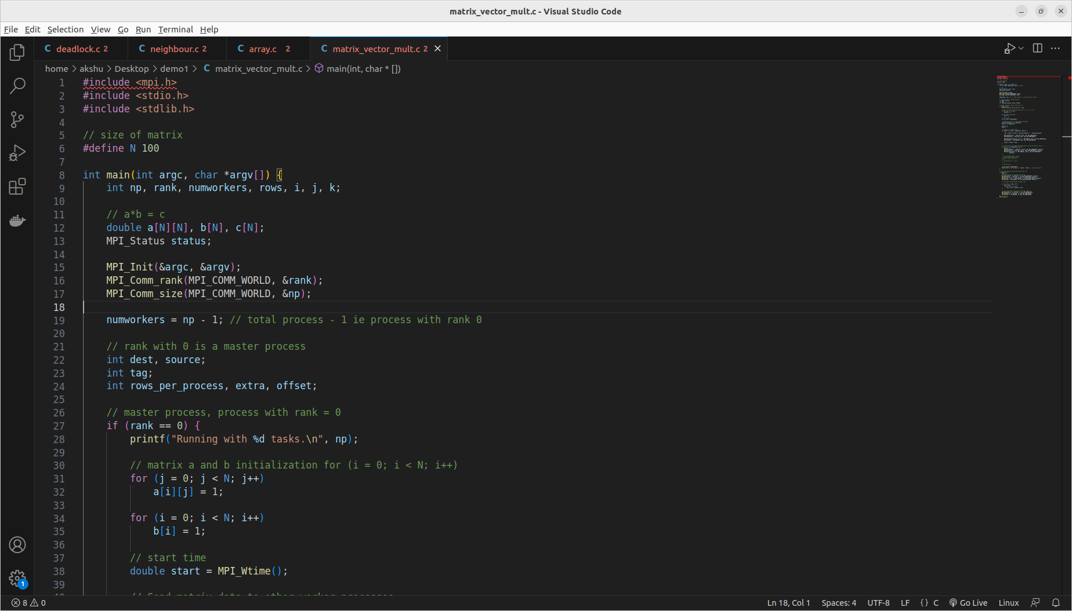

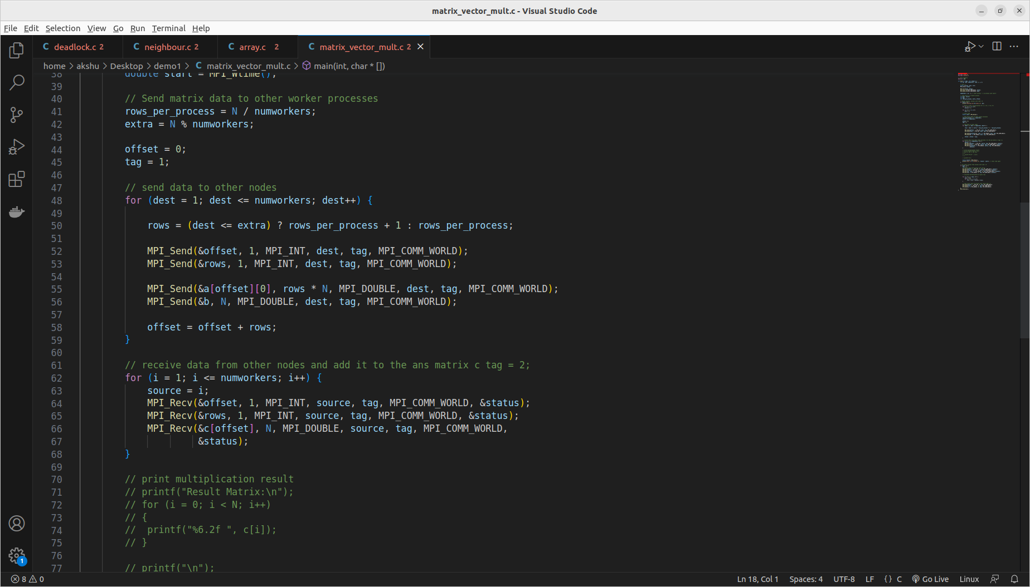

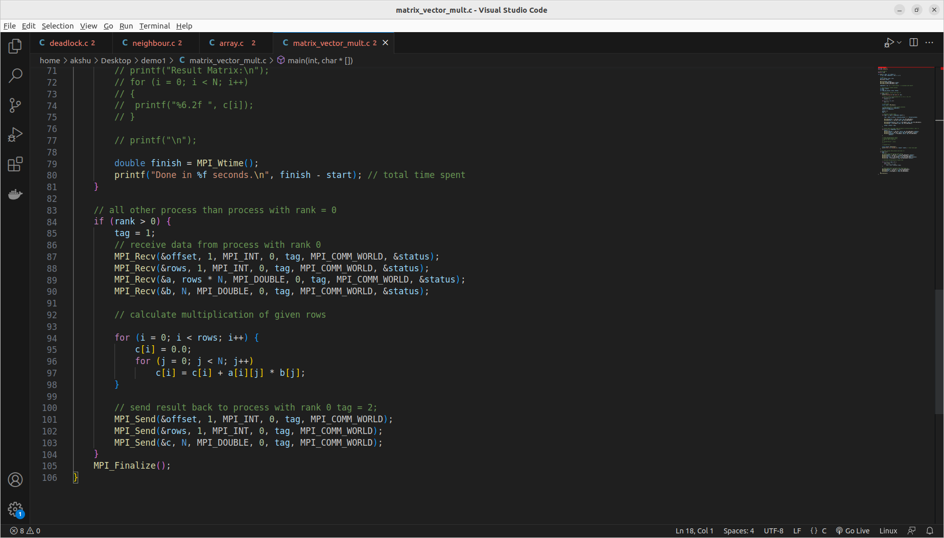

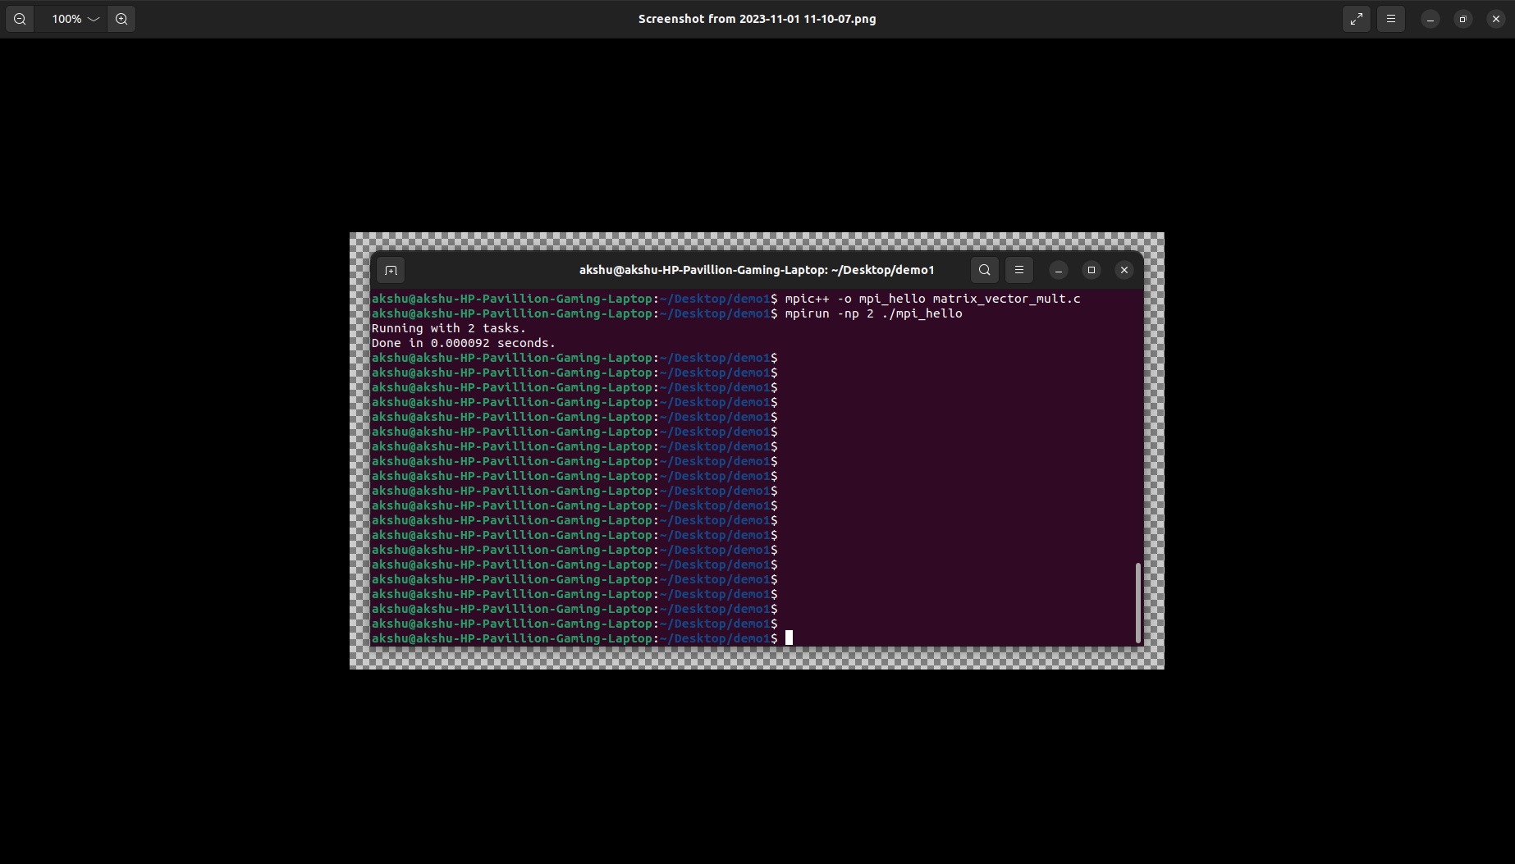

## Implement Matrix-Matrix Multiplication using MPI. Use different number of processes and analyze the performance.

#include <mpi.h>

#include <stdio.h>

#define SIZE 4 /* Size of matrices */

int A[SIZE][SIZE], B[SIZE][SIZE], C[SIZE][SIZE];

void fill_matrix(int m[SIZE][SIZE])

{

static int n = 1;

int i, j;

for (i = 0; i < SIZE; i++)

for (j = 0; j < SIZE; j++)

m[i][j] = n++;

}

void print_matrix(int m[SIZE][SIZE])

{

int i, j = 0;

for (i = 0; i < SIZE; i++) {

printf("\n\t| ");

for (j = 0; j < SIZE; j++)

printf("%2d ", m[i][j]);

printf("|");

}

}

int main(int argc, char *argv[])

{

int myrank, P, from, to, i, j, k;

int tag = 666; /* any value will do */

MPI_Status status;

MPI_Init(&argc, &argv);

MPI_Comm_rank(MPI_COMM_WORLD, &myrank); /* who am i */

MPI_Comm_size(MPI_COMM_WORLD, &P); /* number of processors */

/* Just to use the simple variants of MPI_Gather and MPI_Scatter we */

/* impose that SIZE is divisible by P. By using the vector versions, */

/* (MPI_Gatherv and MPI_Scatterv) it is easy to drop this restriction. */

if (SIZE % P != 0) {

if (myrank == 0)

printf("Matrix size not divisible by number of processors\n");

MPI_Finalize();

exit(-1);

}

from = myrank * SIZE / P;

to = (myrank + 1) * SIZE / P;

/* Process 0 fills the input matrices and broadcasts them to the rest */

/* (actually, only the relevant stripe of A is sent to each process) */

if (myrank == 0) {

fill_matrix(A);

fill_matrix(B);

}

double start = MPI_Wtime();

MPI_Bcast(B, SIZE * SIZE, MPI_INT, 0, MPI_COMM_WORLD);

MPI_Scatter(A[to], SIZE * SIZE / P, MPI_INT, A[from], SIZE * SIZE / P, MPI_INT, 0, MPI_COMM_WORLD);

printf("computing slice %d (from row %d to %d)\n", myrank, from, to - 1);

for (i = from; i < to; i++)

for (j = 0; j < SIZE; j++) {

C[i][j] = 0;

for (k = 0; k < SIZE; k++)

C[i][j] += A[i][k] * B[k][j];

}

MPI_Gather(C[from], SIZE * SIZE / P, MPI_INT, C[to], SIZE * SIZE / P, MPI_INT, 0, MPI_COMM_WORLD);

if (myrank == 0) {

double finish = MPI_Wtime();

// printf("\n\n");

// print_matrix(A);

// printf("\n\n\t * \n");

// print_matrix(B);

// printf("\n\n\t = \n");

// print_matrix(C);

// printf("\n\n");

printf("Exection Time: %f\n", finish - start);

}

MPI_Finalize();

return 0;

}

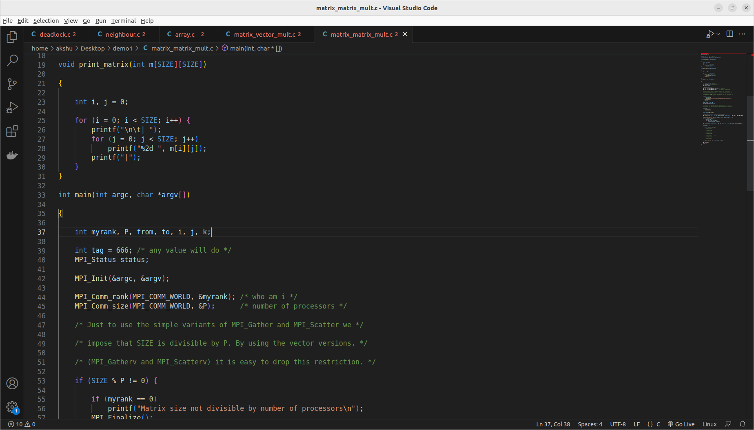

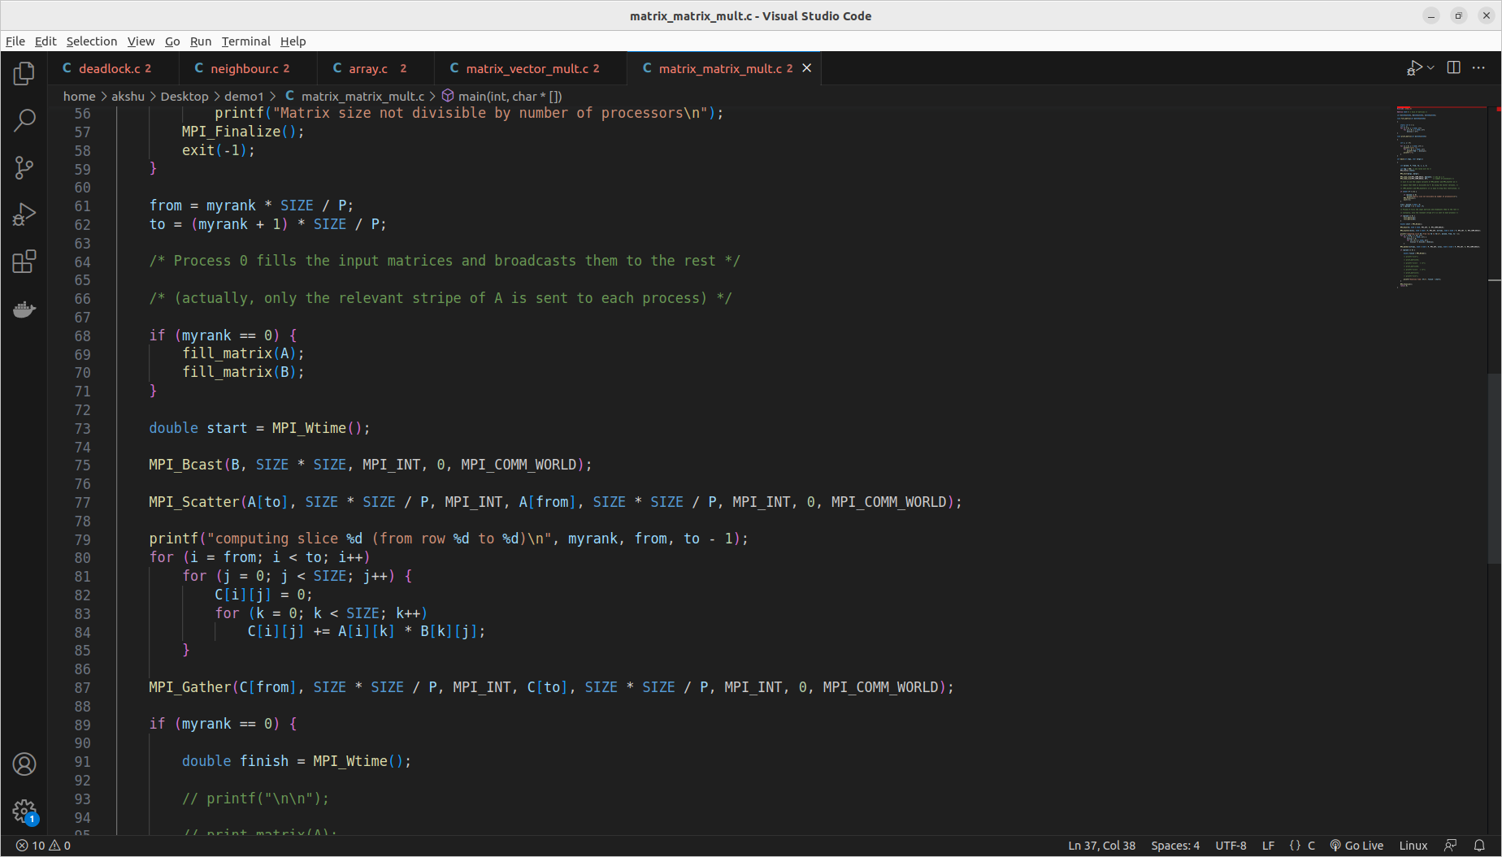

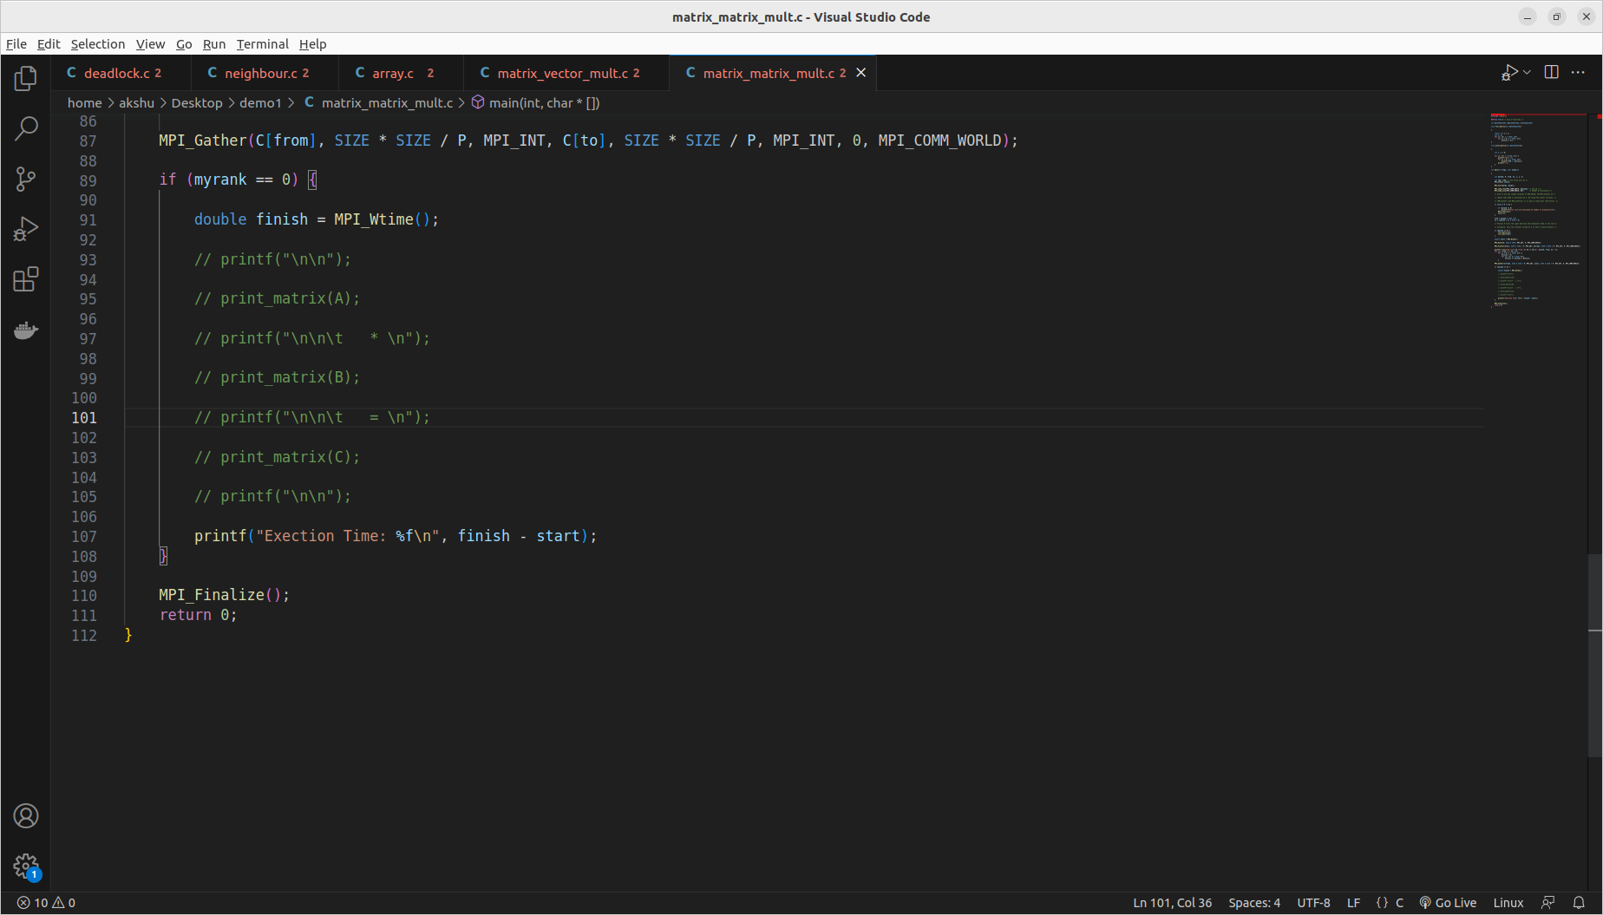

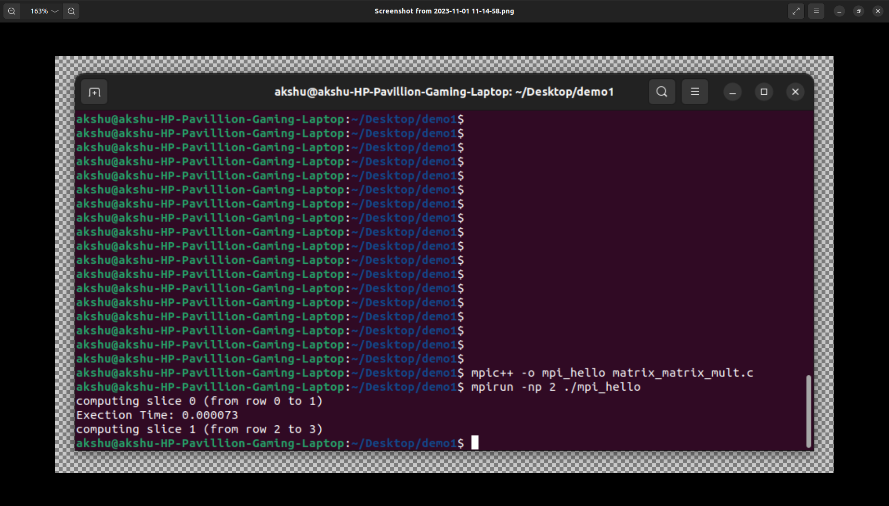

**GitHub Link:**

<https://github.com/Siddhish16/HPC-Assignments>